Air Conditioning Standard Quote for Summer of 2017 / 2018

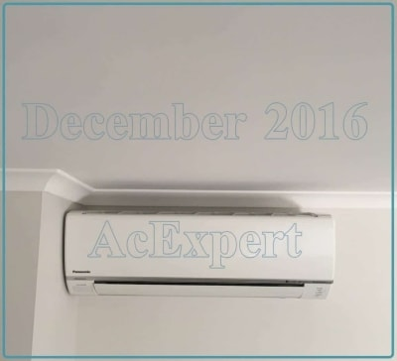
Prices Valid until June 2018 or thereabouts

INSTALL ONLY
Our install only price if you already bought the unit :

Up to 4 kw = $550
Up to 6kw = $600
Up to 8kw = $650
These prices cover 90% of all installs completely. If you have a nice wall which has the outside world behind it...
Empty space on that wall to fit 960mm width for small units and 1100mm width for large. You need 350mm height for both... Then the prices above cover it all. Same for the supply and install prices below. See last page of this quote for a diagram explaining installation options and costs. Prices include removal and disposal of old units.

Our Air Conditioners Supplied and installed complete
Include GST, electrical, bracket - Everything. Single story home install / business

Brand of unit | 2.5kw | 3.5kw | 5.0kw | 6.3kw | 7.1kw | 8.0kw
Panasonic | $1350 | 1500 | 1900 | $2200 | 2350 | 2950
Mitsubishi Heavy | $1400 | 1600 | 2000 | 2300 | 2450 | 2950
Mitsubishi Electric | Not stocking these ones any more
Daikin L series | $1400 | 1600 | 2000 | 2300 | 2500 | 3200
Rinnai | Even Daikin you have to be special to get a daikin
Carrier | None of these, Rinnai or Mit. Electric. Don’t stock them
After 1000+ installs in two years we’re convinced Panasonic + Daikin are the quietest and have
The least warranty issues*.
Warranty Calls : Panasonic less than 1 per 100 .... Mitsubishi 2.1 per 100 ......Daikin 1 per 100

Models and brochures :

If you received this quote by email these links will work. They link to PDF brochures of the different brands of unit. If you are looking at a printed version you can try clicking it with your finger, who knows what will happen. In case of unexpected results go home and google the model numbers or jump on our website. Or just take our word for it... They’re good gear. We don’t sell rubbish.

Mitsubishi Heavy
https://airconditioningexpert.com.au/wp-content/uploads/2016/06/MHIAA477_RACSRSeriesNOV2015_p4.pdf

New Mitsubishi Heavy Bronte Range
https://airconditioningexpert.com.au/wp-content/uploads/2018/01/BRONTE_Brochure.pdf

New Mitsubishi Heavy Avanti Range
https://airconditioningexpert.com.au/wp-content/uploads/2018/01/AVANTI_brochure.pdf

Panasonic
http://www.panasonic.com/au/consumer/air-conditioning-ventilation/econavi-reverse-cycle-inverter/cs-cu-z21rkr.html

Mitsubishi Electric
https://airconditioningexpert.com.au/wp-content/uploads/2017/08/Flyer_MSZ-GL_Aug-2016.pdf

Daikin
https://airconditioningexpert.com.au/wp-content/uploads/2017/08/PCSPAU0717-Daikin-Split-Brochure-Block-AU_LR_0.pdf

Energex rebates

Where you can claim $100 - $200 off your installation as well. But be warned. There's no such thing as free money. If you accept this deal you are giving the keys to your air conditioner to Energex. They can turn your air con up down or off whenever it suits them. In practise they don't much, but you can bet when they do it's the hottest day of the year. The only units I would consider putting these in are the bedroom sized ones. The reason is that by night time the network demand is down, and rarely would Energex need to use the receivers to turn your air con off at night time. As long as you are informed about the promotion we will install them, but those are the details.

More Information from Energex here :

https://www.energex.com.au/home/control-your-energy/positive-payback-program/positive-payback-for-households

Mitsubishi Heavy SRK ** ZMAS Brochure extract.
These come in 2.5kw – 8.0kw and are priced above
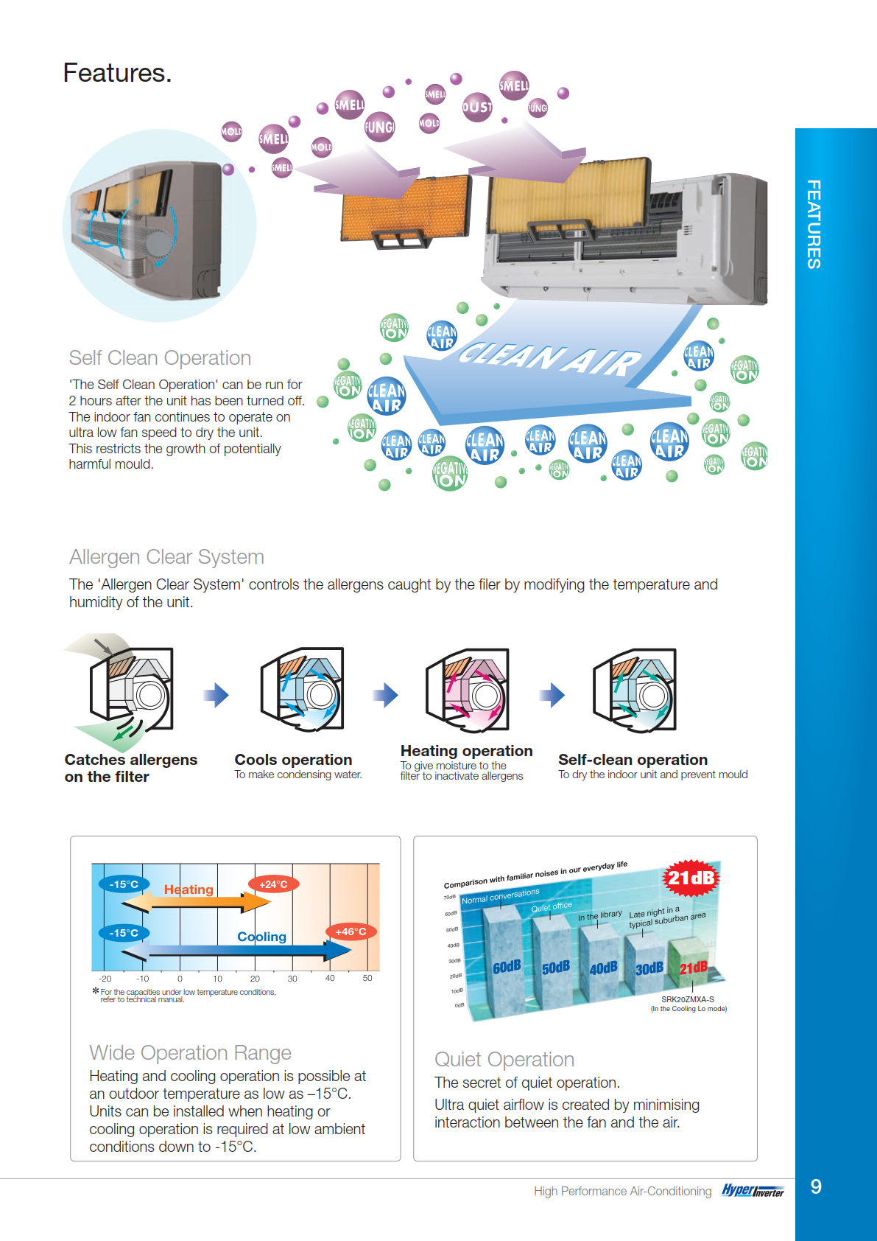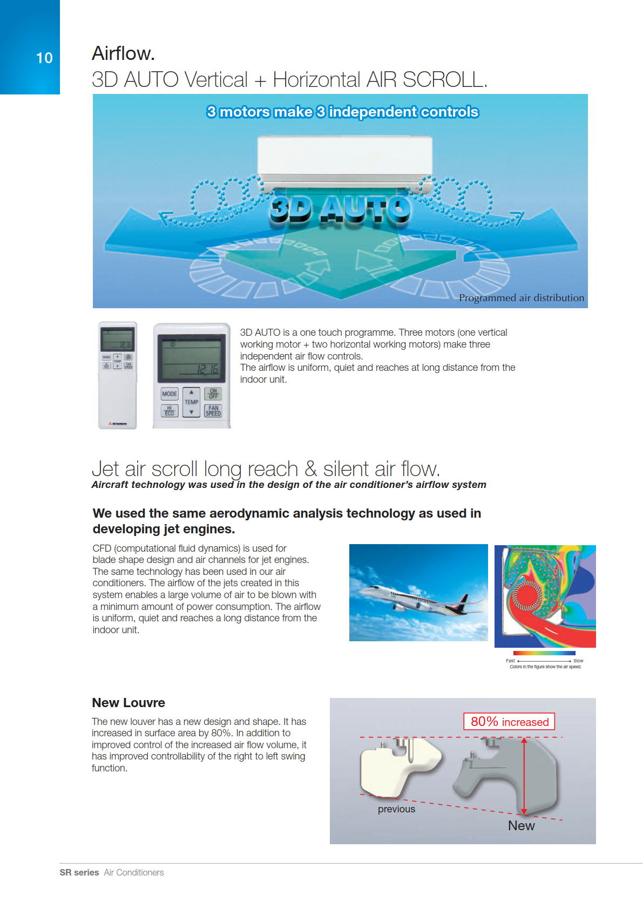
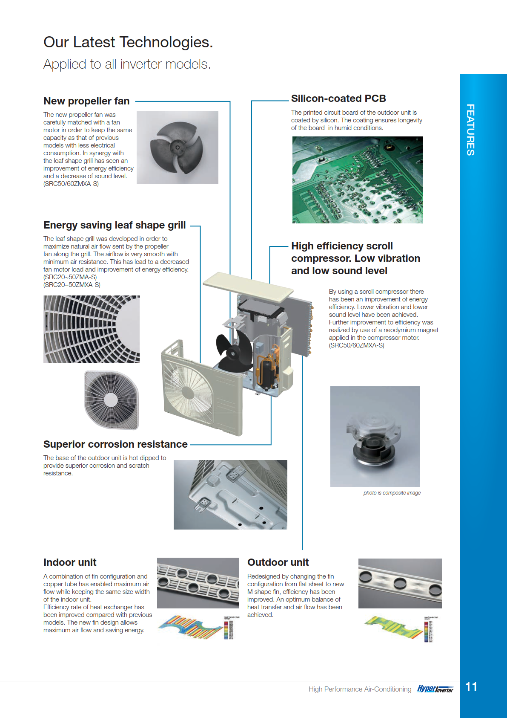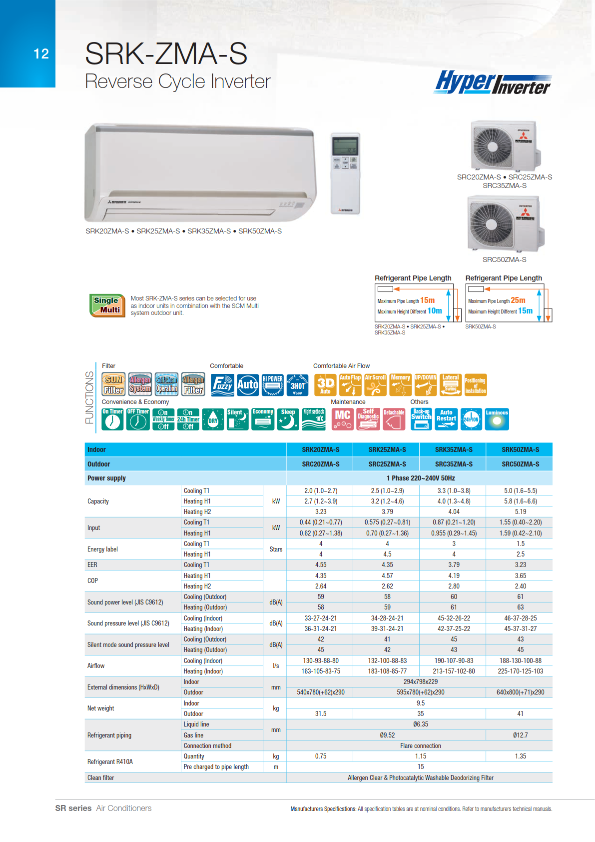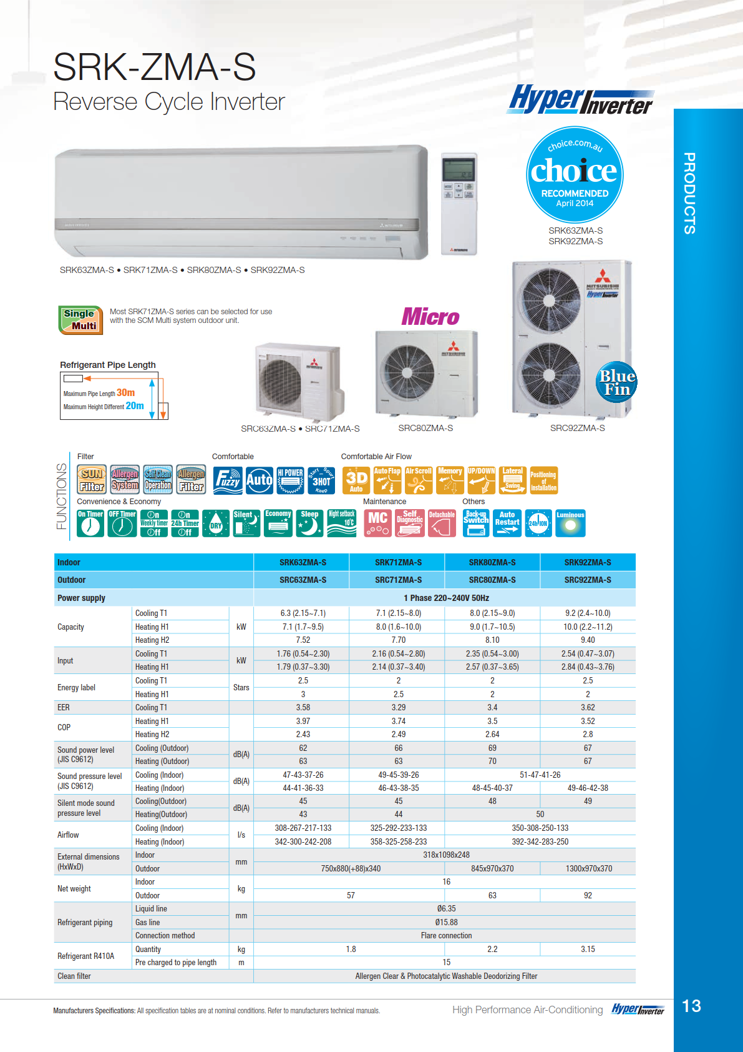

Panasonic TKR 2017 Range
These come in 2.5kw – 8.0kw and are priced above

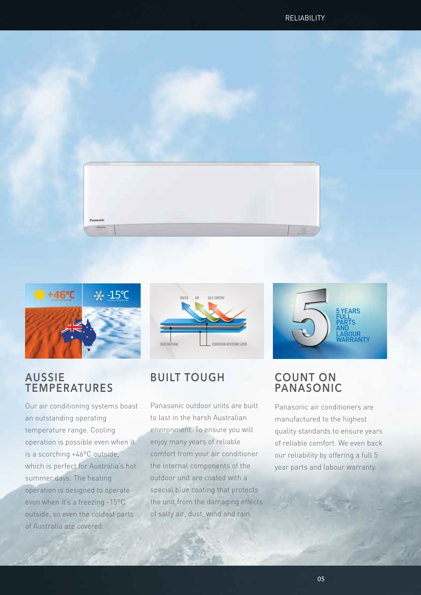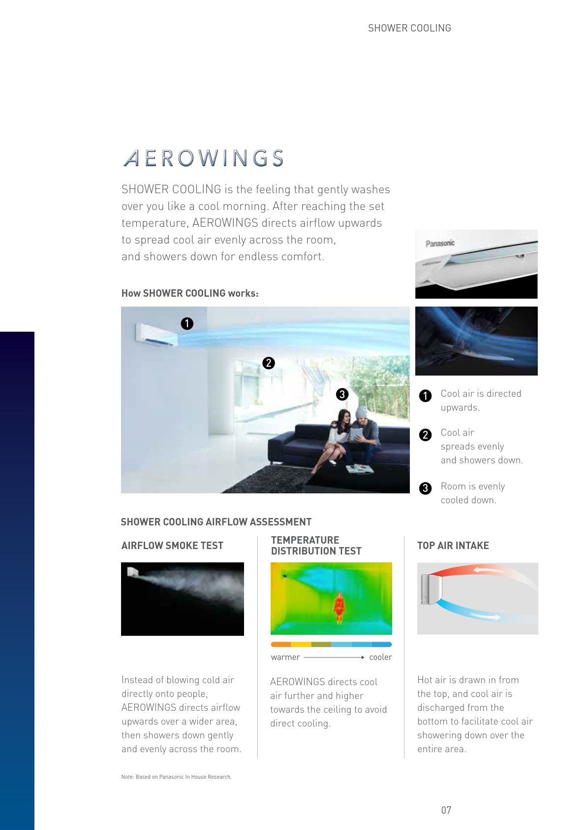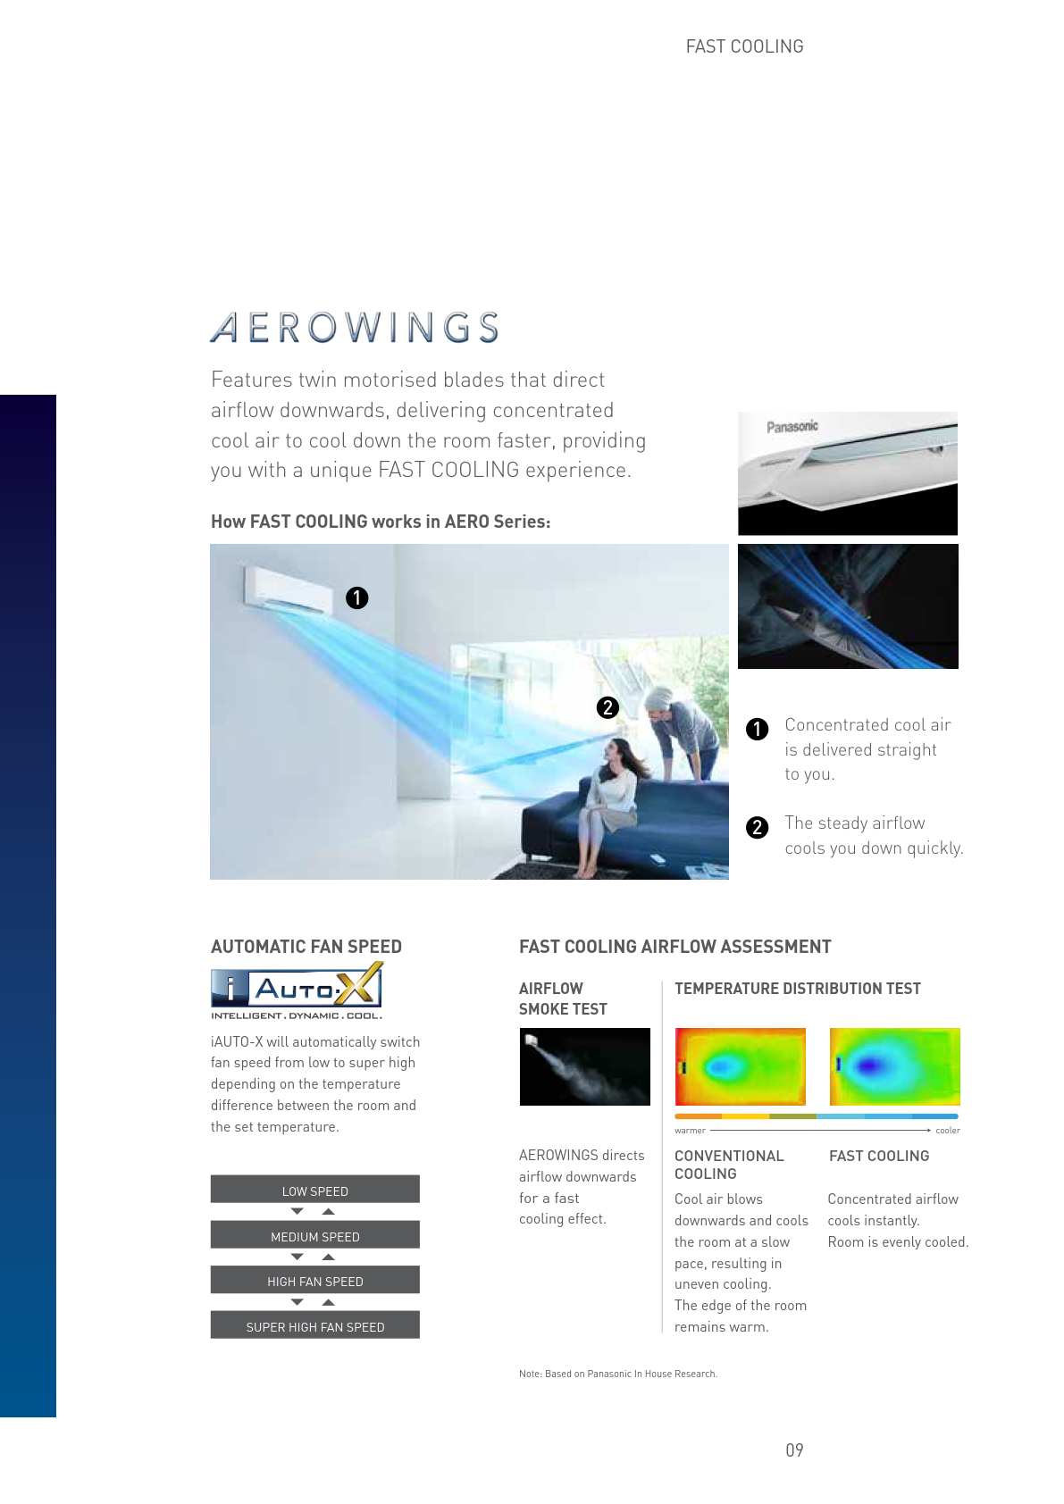

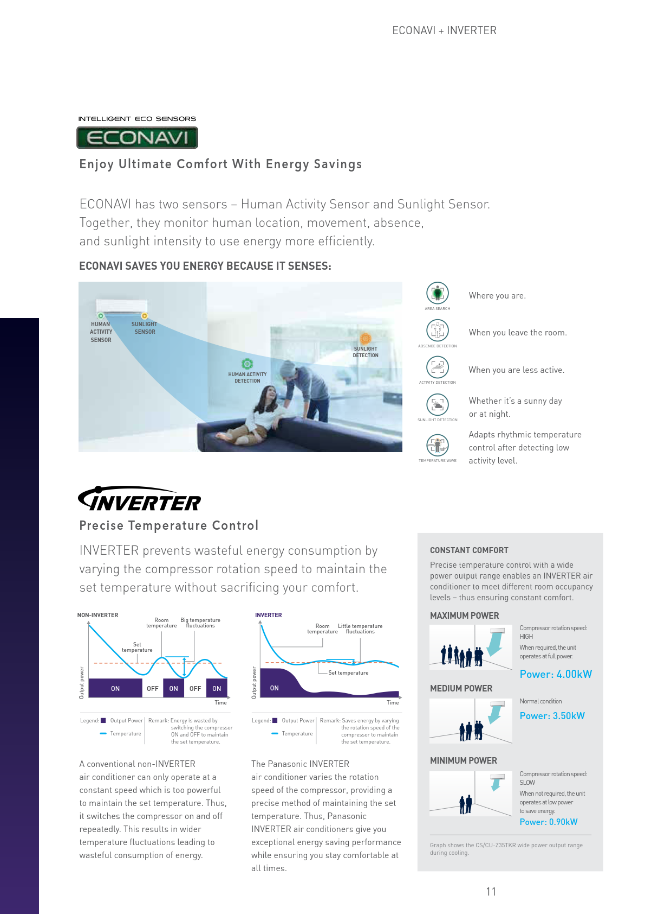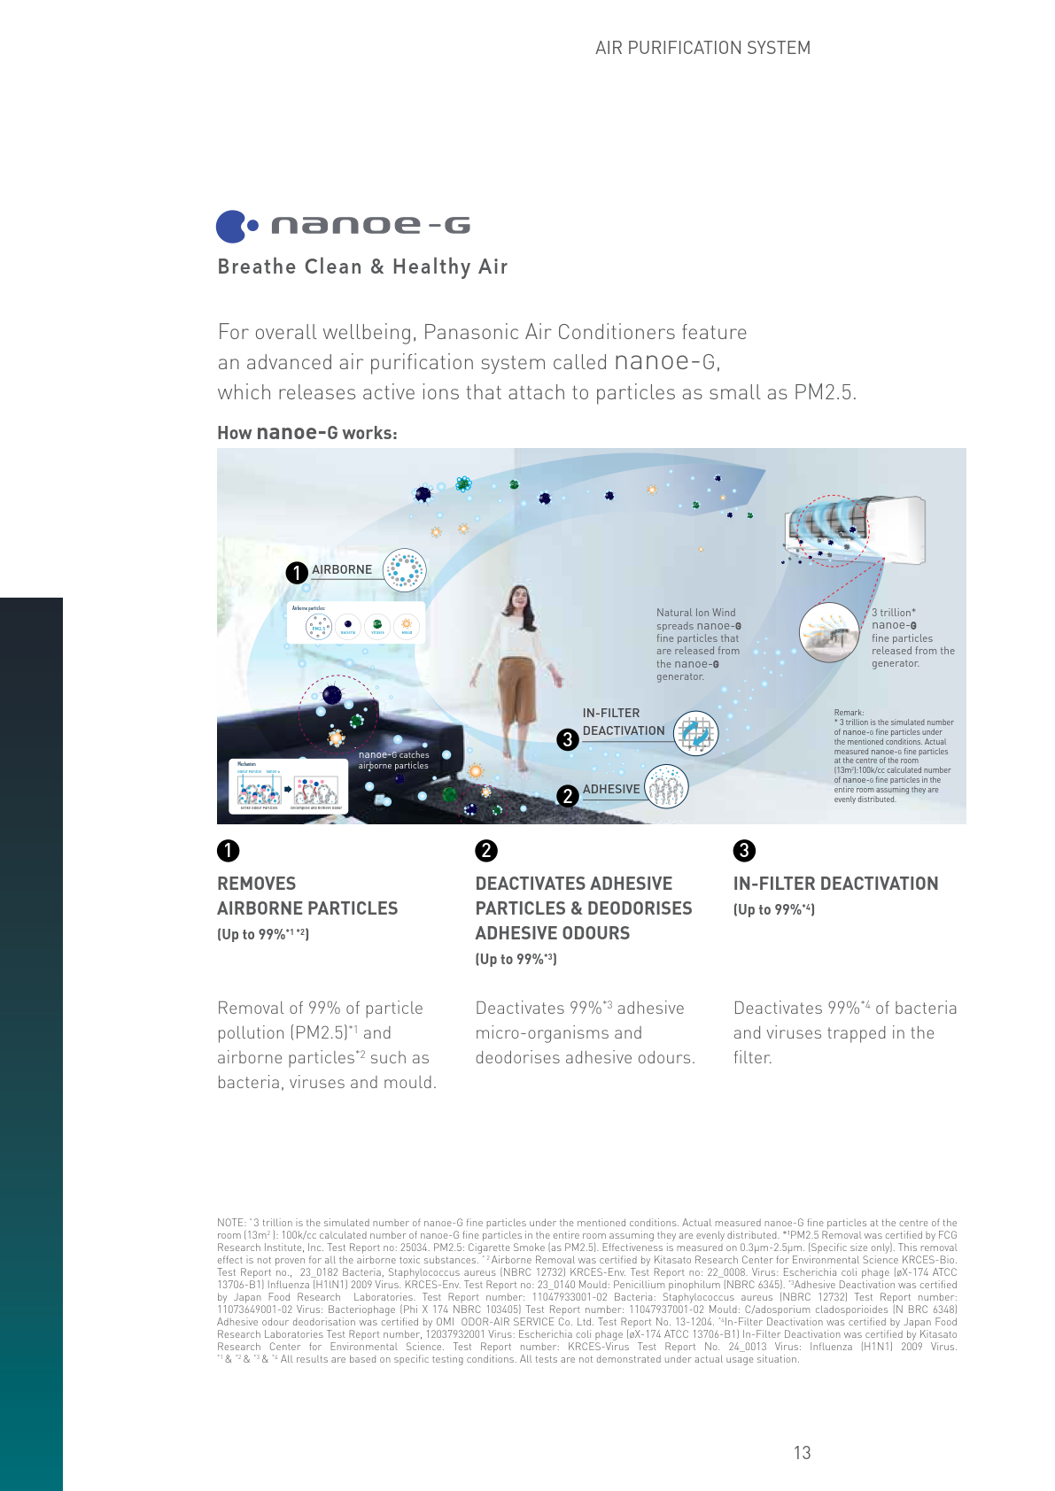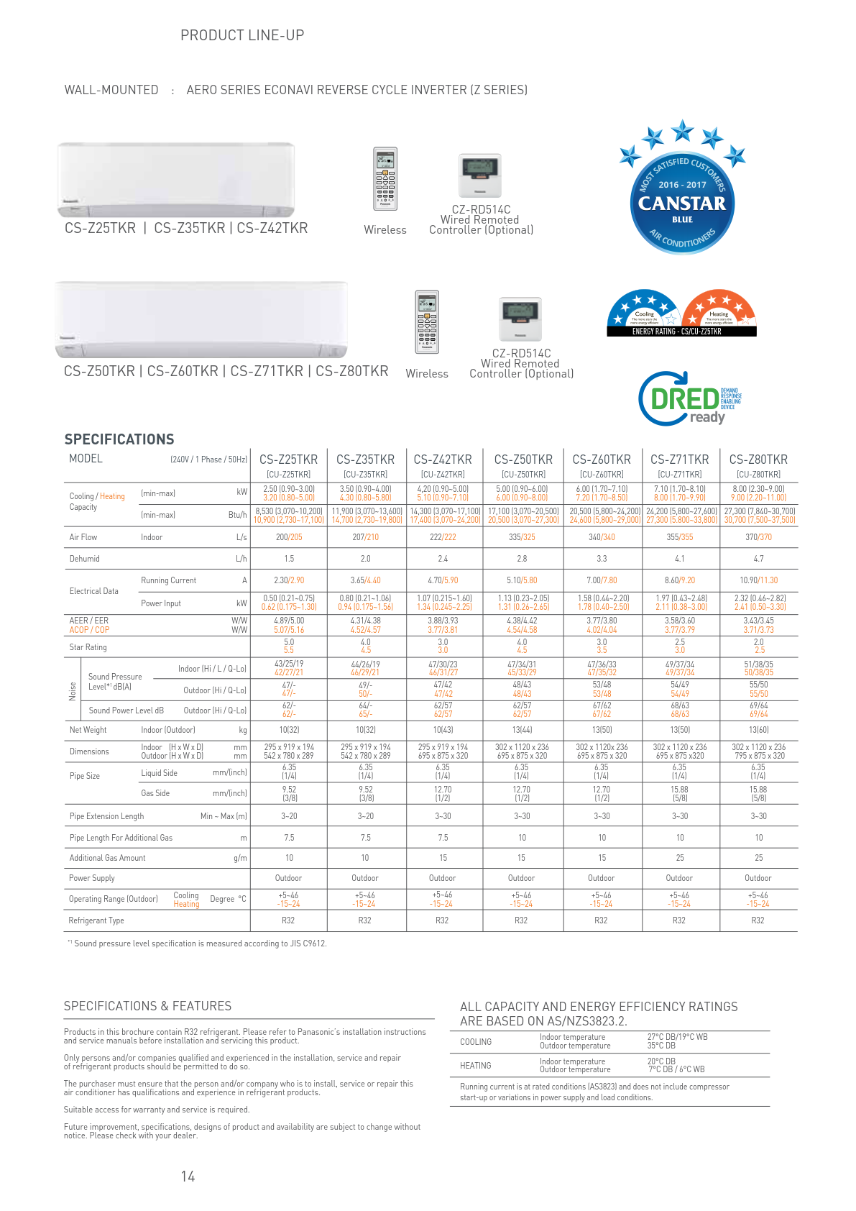

Below are examples of a Split System operating
At 22c on a 35c day outside, with windows and doors closed

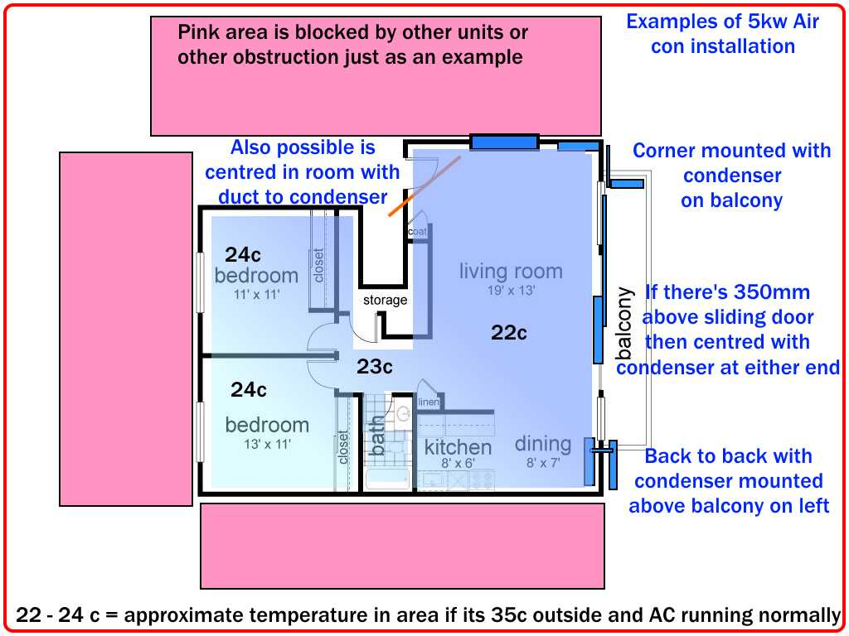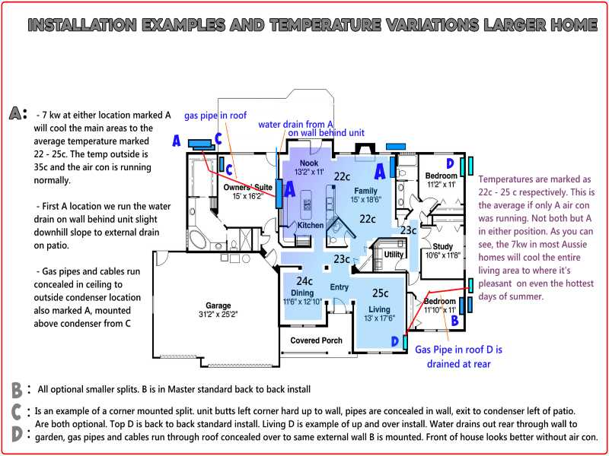

Examples of our installations :

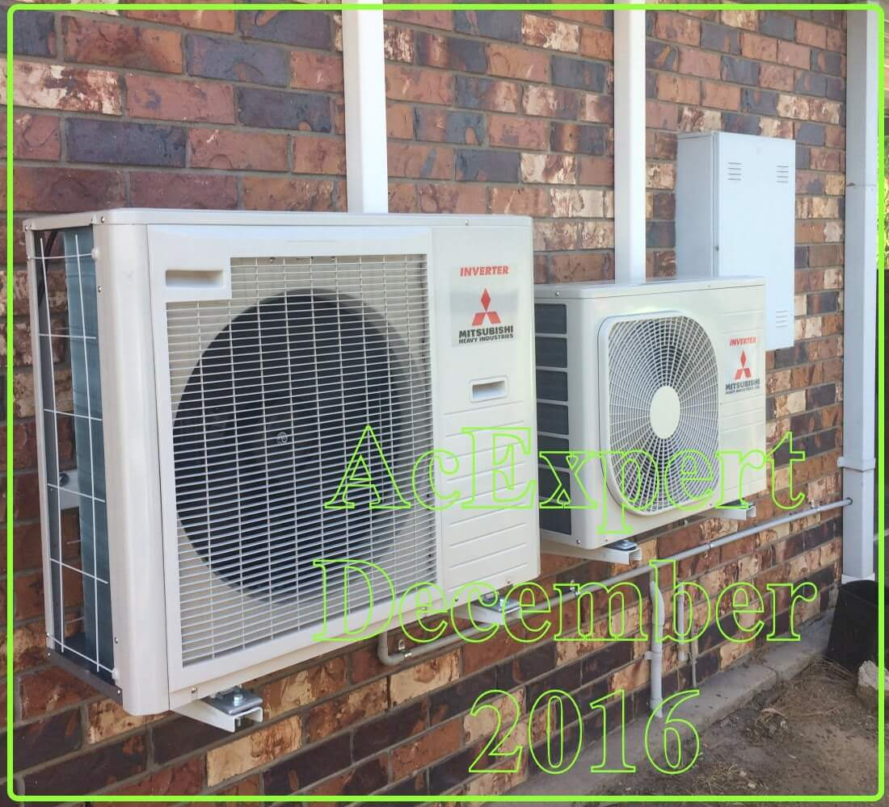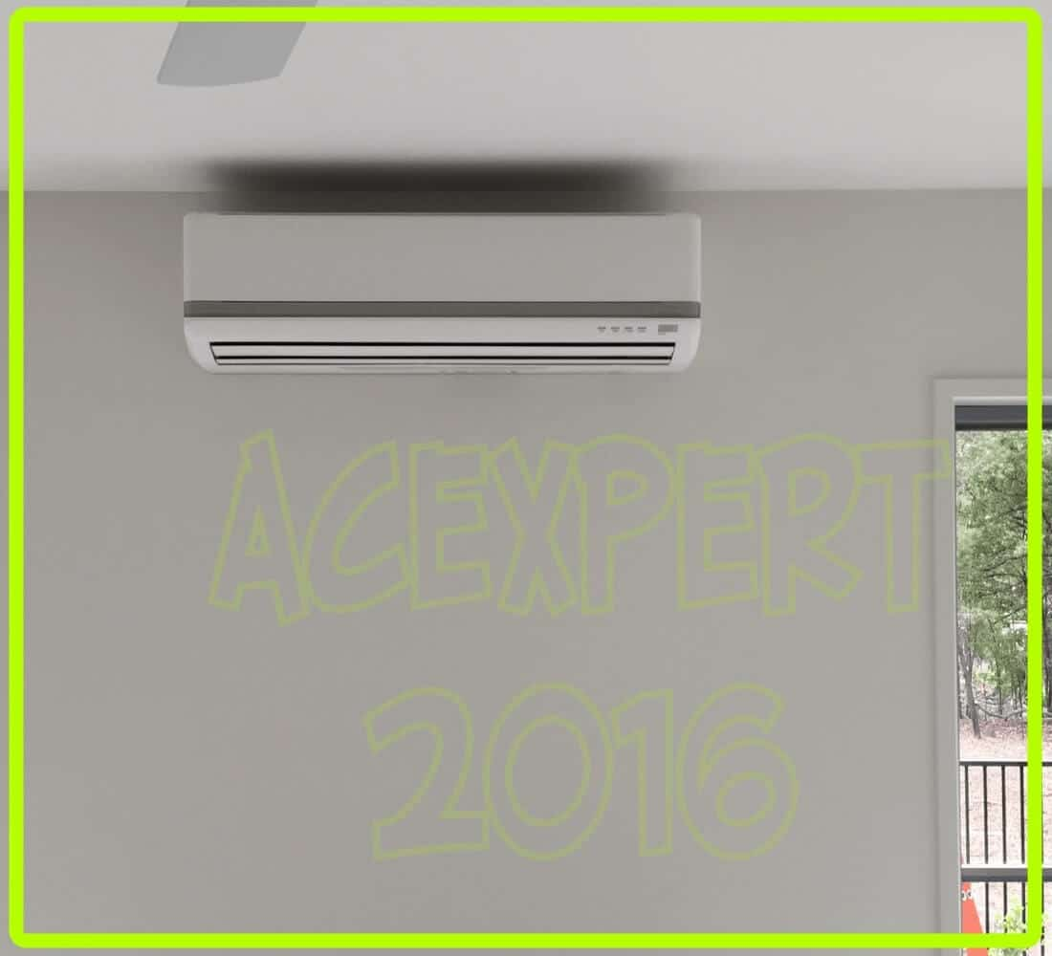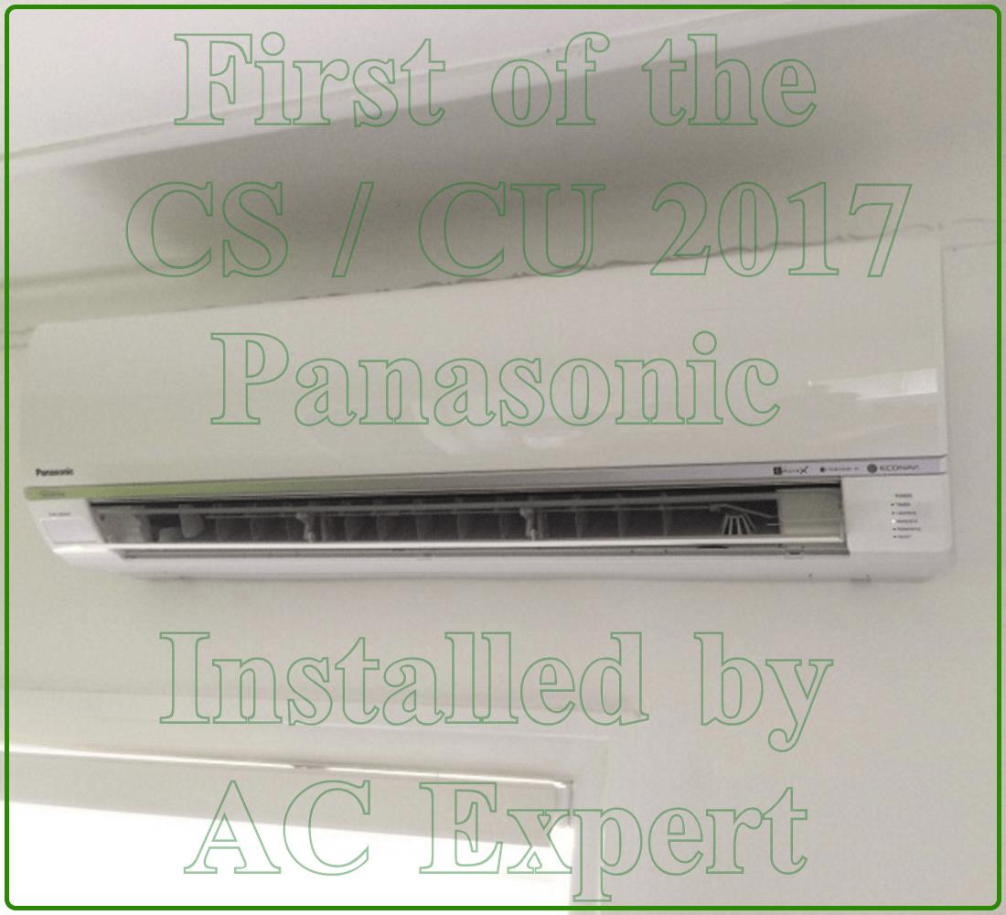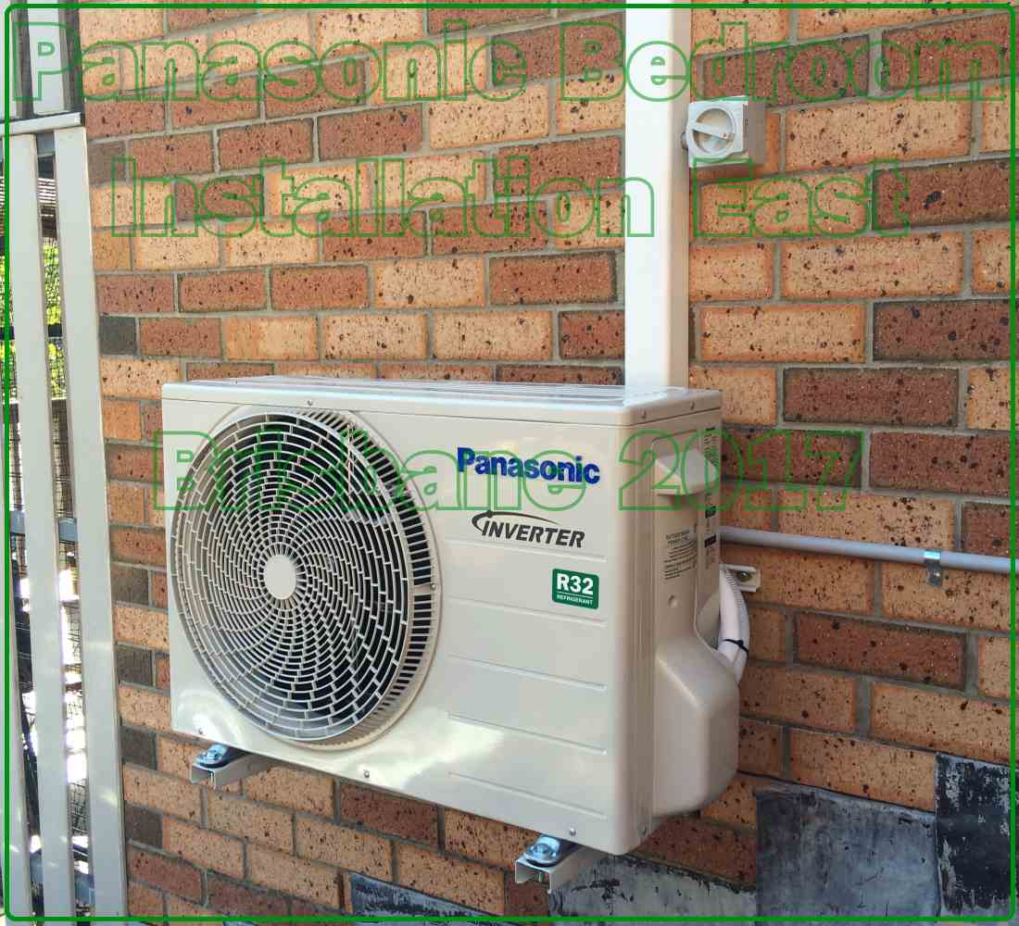

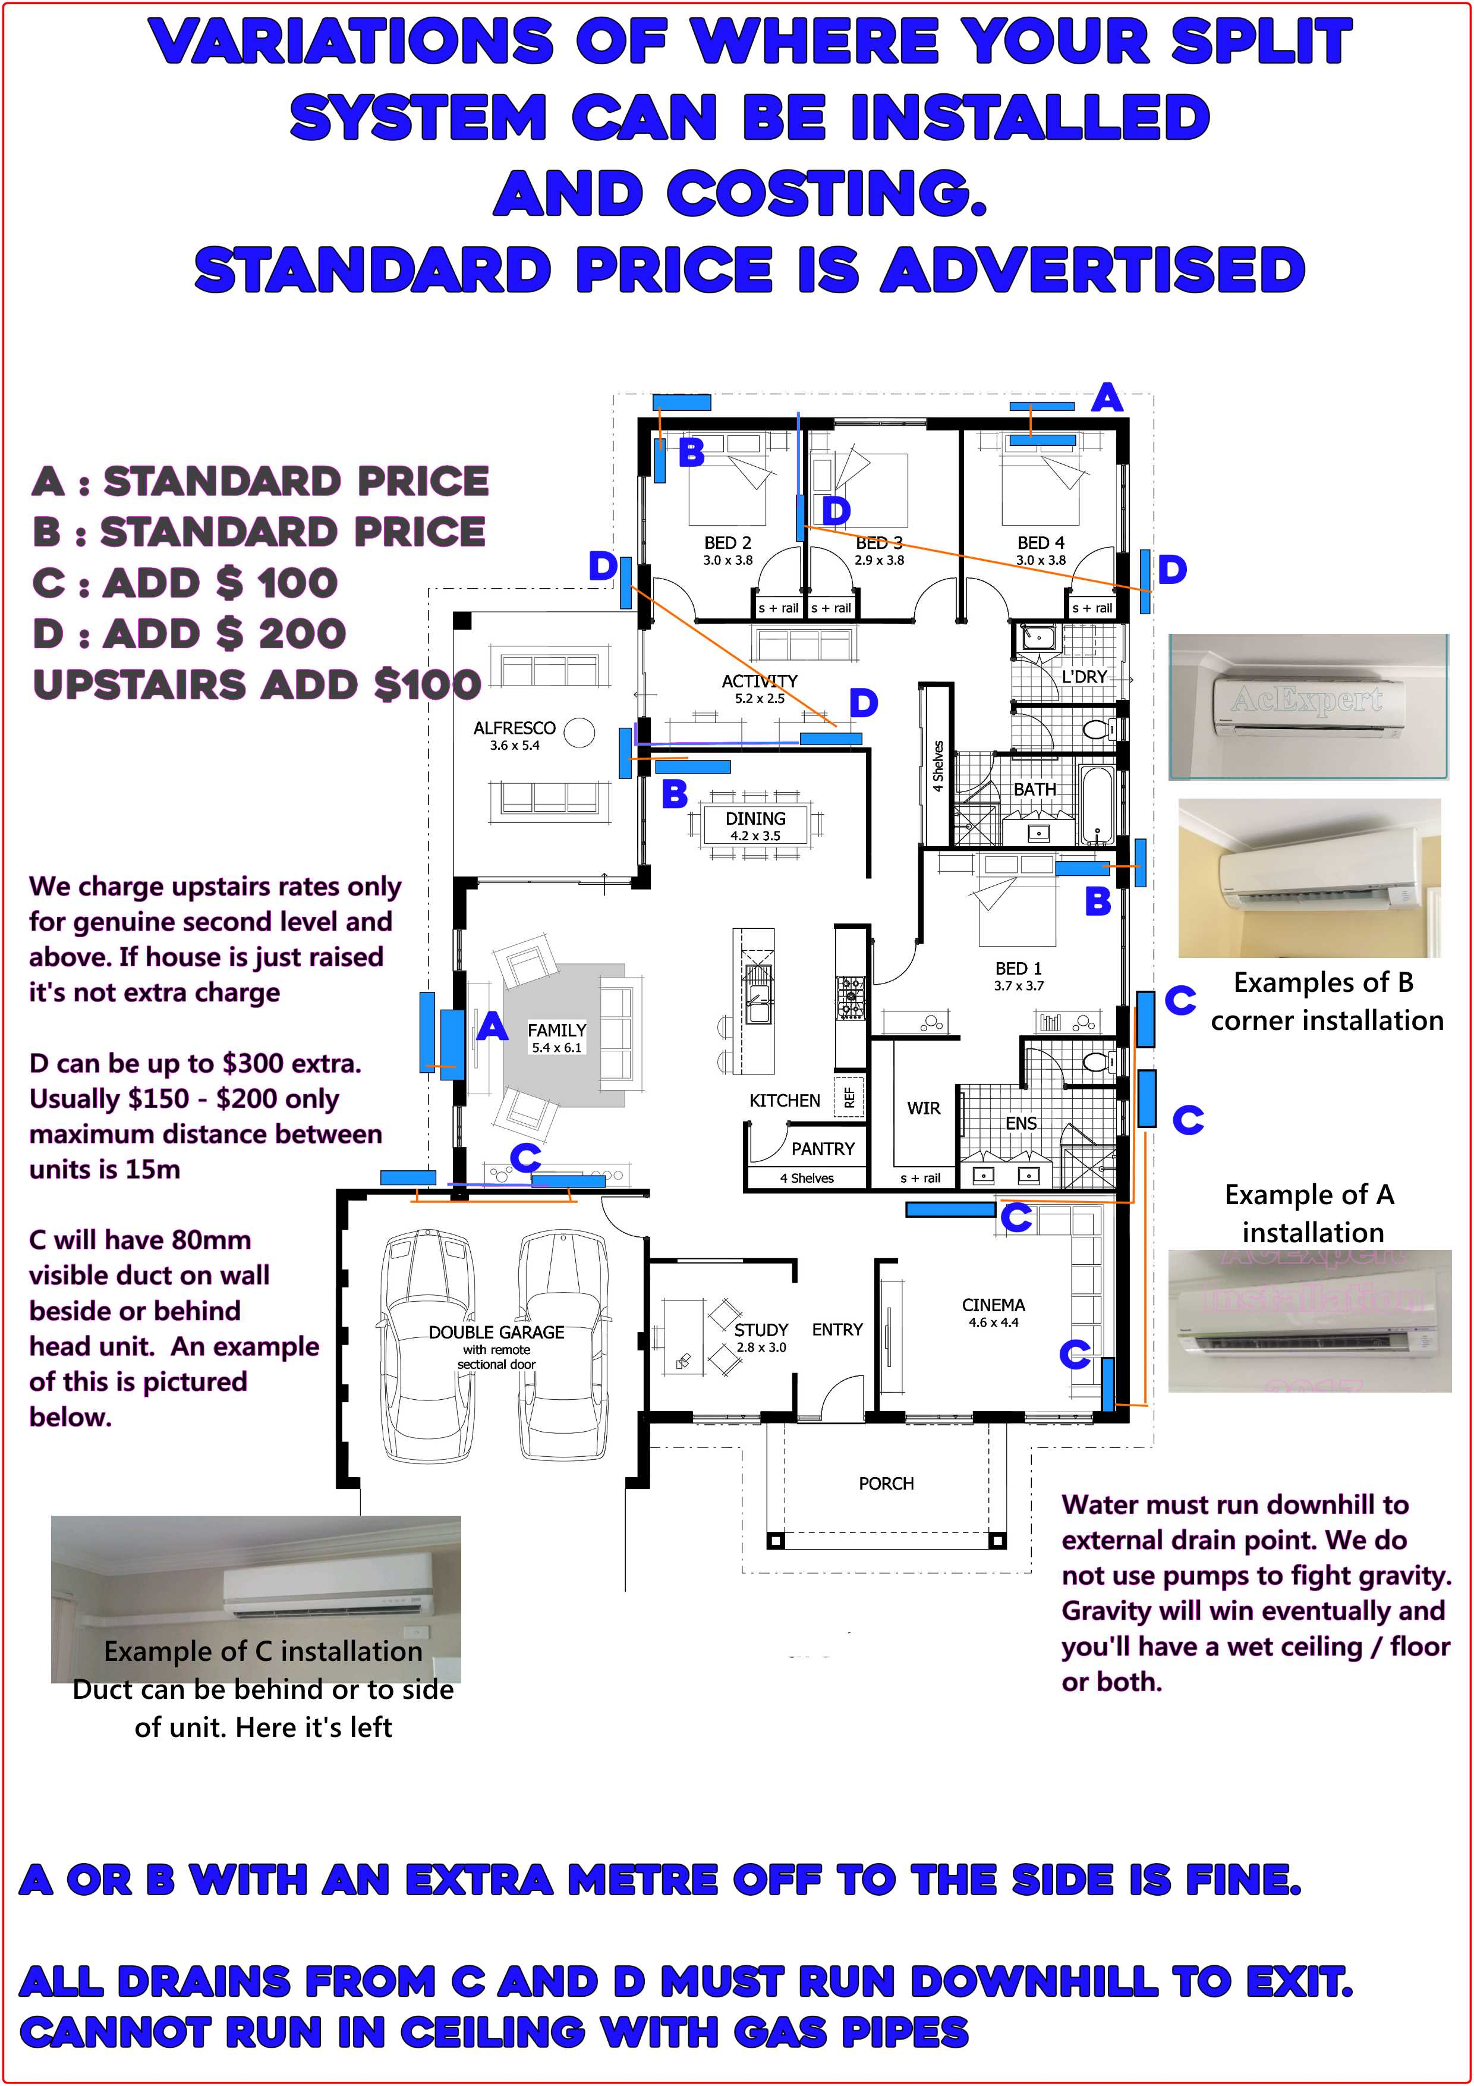

We are able to install within a week from your order. If you have a baby or are elderly (Australians) or some bizarre emergency we can move stuff around to get you in faster. However : Unless it’s either of the above : Being hot is not a bizarre emergency. You get installed in your turn.
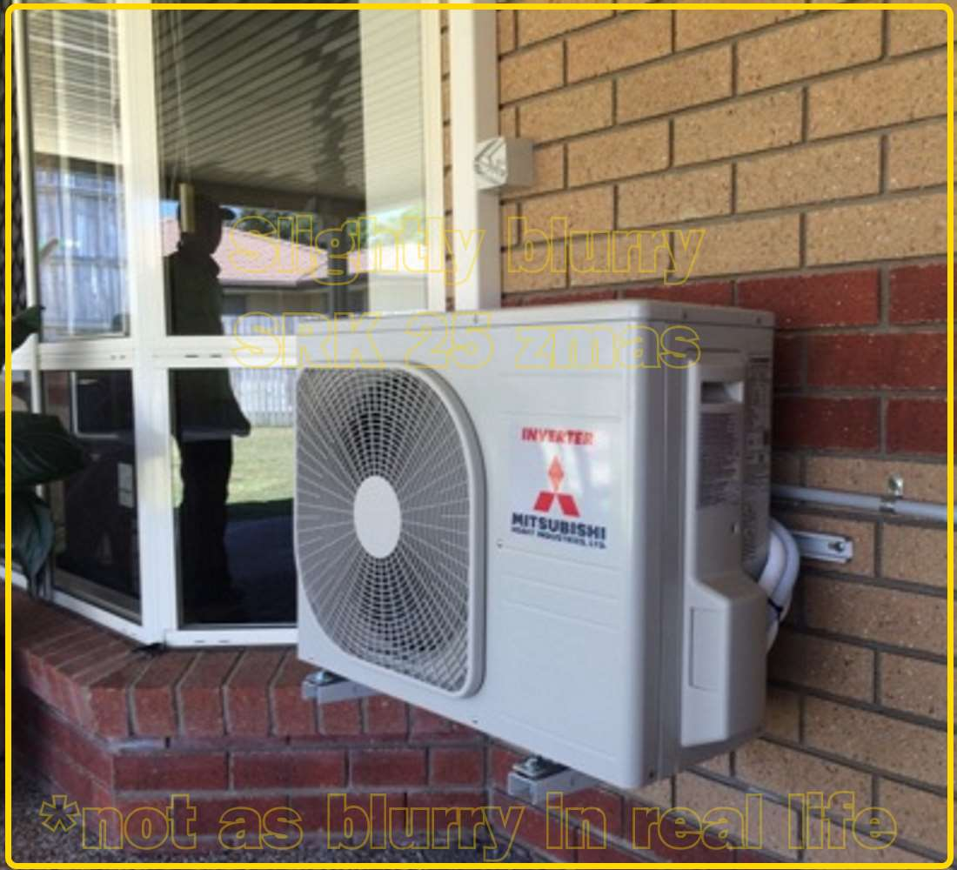
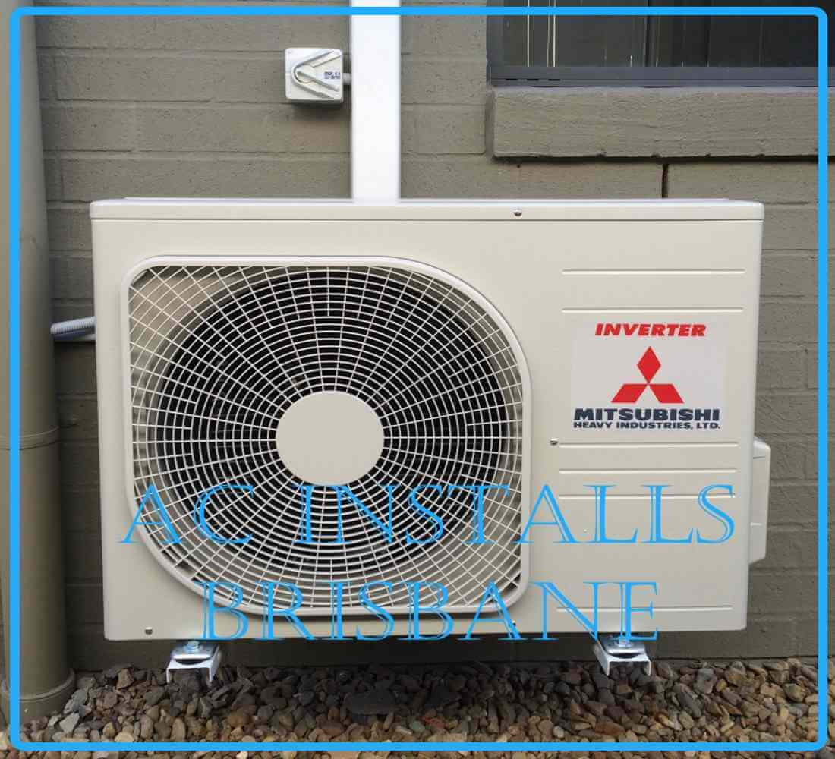
Hope that covers all your quote / questions.

Thank you, regards
Simon Hickey

AcExpert
0411 739 333
acexpert@email.com
airconditioningexpert.com.au

